**Software Architecture Document (SAD)**

Table of Contents

Introduction 3

System Context 4

Containers and Tech Choices 5

Components 6

Class Diagram 7

# Introduction

In this document, I present an overview about the architecture about the web app I am working on using c4 model.

# System Context

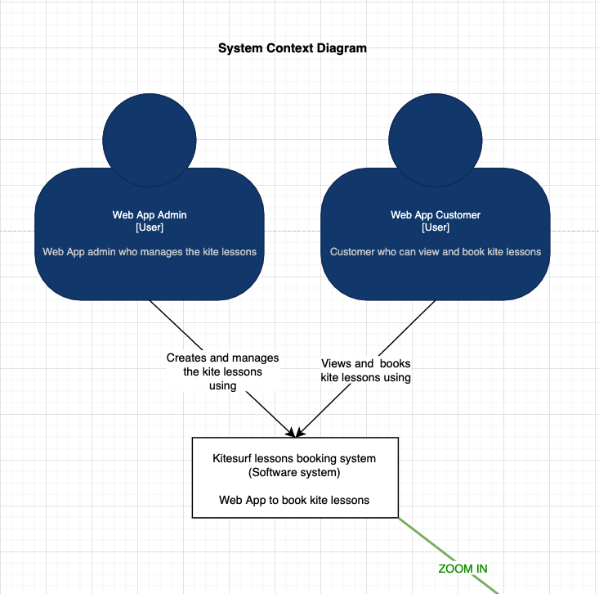

# Containers and Tech Choices

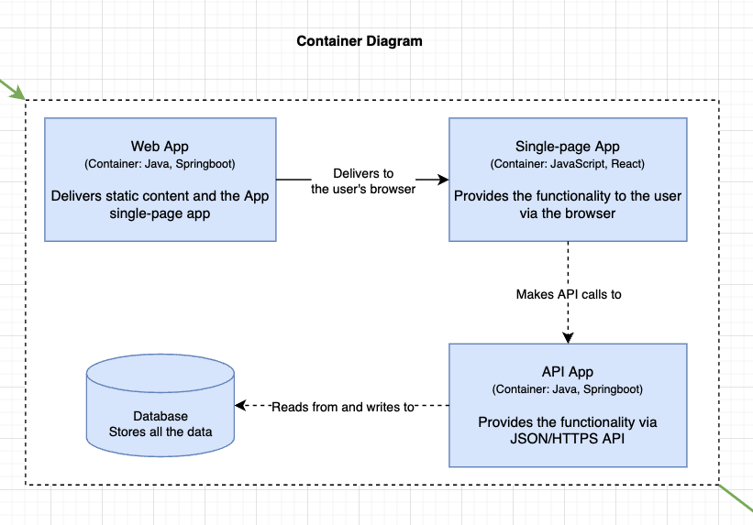

# Components

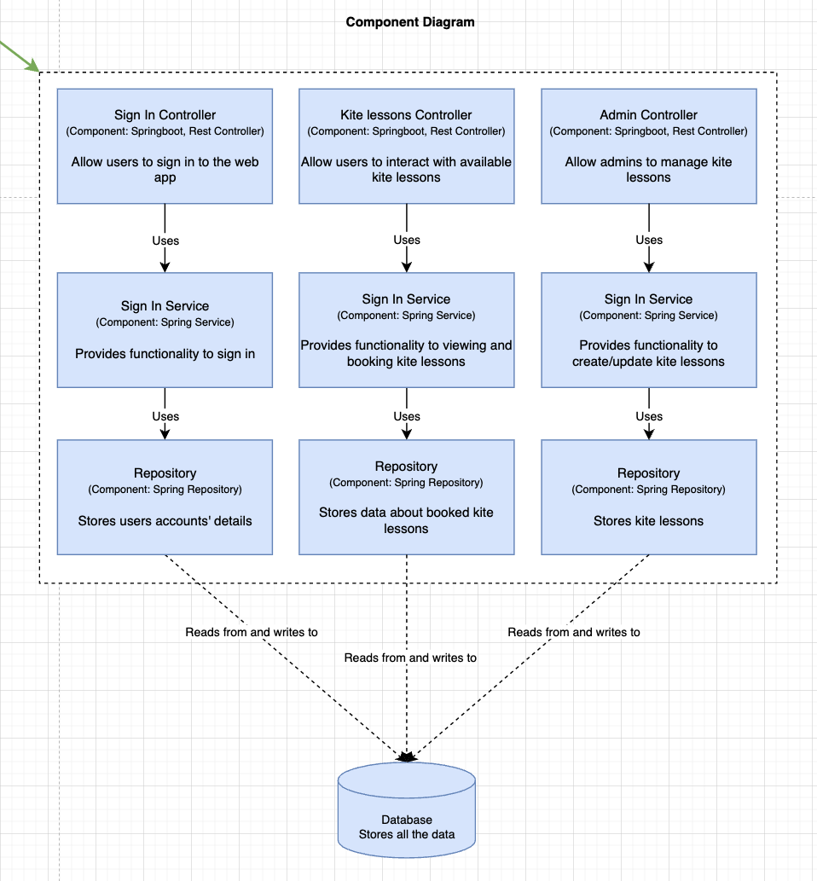

# Class Diagram

